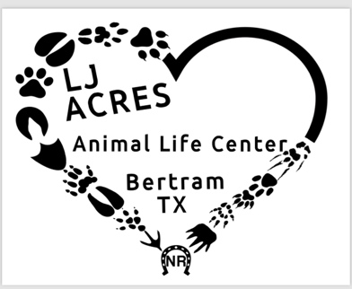

LJ Acres Animal Life Center Surrender Application
213 Samuel Drive
Bertram, TX 78605
(512)734-4890
lj.acresbertram@gmail.com

Date:
Name:
Address:
Phone number:
Email address:

What is the sex and breed of the animal you are surrendering?

What is the animal’s approximate age?

Is this animal spayed or neutered?

Has this animal ever been to the veterinarian and if so, why? And please provide the veterinarians information so that we can request the records.

Why are you surrendering your animal?

Are there any additional comments that you would wish to add about the animal you are surrendering?

Your donation to assist with future care, feeding and housing is:

We reserve the right to adopt out your surrender. We are an animal rescue and sometimes we have to adopt out animals that have been surrendered. If the animal has been to the vet, you will have to call them and release the animal to us so that we can get the records. This application serves as a surrender contract.

Thank you for choosing LJ Acres

___________________________________________________________
Printed name Date

_______________________________________
Signature

